i

# COLLEGE MANAGEMENT SYSTEM USING SAP

**ABAP**

## A PROJECT REPORT

**(SAP ABAP WORK BENCH FUNDAMENTALS - 40 SAT 01)**

***Submitted by***

**M RAJIK AHAMED 1614175**

***In partial fulfillment of the requirement***

***For the award of the degree***

***Of***

**BACHELOR OF ENGINEERING**

**K.S.RANGASAMY COLLEGE OF TECHNOLOGY**

**TIRUCHENGODE – 637215**

**(An Autonomous Institution, Affiliated to Anna University Chennai and Approved by AICTE, New Delhi)**

**OCTOBER 2018**

ii

**BONAFIDE CERTIFICATE**

Certified that this Project report titled **“COLLEGE MANAGEMENT SYSTEM USING SAP** is the bonafide work of  **M RAJIK AHAMED (1614175)** who carried out the project under mysupervision. Certified further, that to the best of my knowledge the work reported herein does not form part of any other project report or dissertation on the basis of which a degree or award was conferred on an earlier occasion on this or any other candidate.

**SIGNATURE**

Dr.B.G.GEETHA M.E., Ph.D.

HEAD OF THE DEPARTMENT

Professor

Department of Computer Science and

Engineering,

K.S.Rangasamy College of Technology,

Tiruchengode - 637 215.

**SIGNATURE**

Mr. N. GIRIDHARAN, M.E.,

SUPERVISOR

Assistant Professor

Department of Computer Science ' and Engineering,

K.S.Rangasamy College of

Technology, Tiruchengode 637215.

Submitted for the viva-voce examination held on

**Internal Examiner**

## DECLARATION

Certified that this Project report titled “**COLLEGE MANAGEMENT SYSTEM USING SAP”** is the bonafide work of **M RAJIK AHAMED (1614175), and B NAVEEN KUMAR ( )** who carried out the project under my supervision. Certified further, that to the best of my knowledge the work reported herein does not form part of any other project report or dissertation on the basis of which a degree or award was conferred on an earlier occasion on this or any other candidate.

### Signature

M RAJIK AHAMED

B NAVEEN KUMAR

**Place:** Tiruchengode

### Date:

iv

**ACKNOWLEDGEMENT**

We wish to express our sincere gratitude to our honourable correspondent **Lion Dr. K. S. RANGASAMY, M.J.F.,** and all the members of K.S.Rangasamy College ofTechnology at this high time for providing necessary facilities to complete the course successfully.

We are very proudly rendering our thankfulness to our principal

**Dr. A.KUMARAVEL, M.TECH., Ph.D.,** for the facilities and theencouragement given by him to the progress and completion of our project.

We regard our earnest and heartfelt gratitude to our beloved Dean/Academic **Dr. K.DURAISWAMY B.E., M.Sc. (Engg.)., Ph.D., MISTE, MIAENG, MCSI** who has beenthe key spring of motivation to us throughout the completion of our course and project work.

We proudly render our immense gratefulness to the Head of the Department **Dr. B.G.GEETHA, M.E., Ph.D., MISTE** for her effective leadership, encouragement andguidance in the project.

We are highly indebted to provide our heart full thanks to our guide

**N.GIRIDHARAN, M.E.,** Assistant professorfor his valuable ideas, encouragement and supportive guidancethroughout the project.

We are indebted to our project co-coordinator **Dr. S.MADHAVI, M.E., Ph.D.,**  for her heart full involvement. We wish to extend our sincere thanks to all faculty members of Computer Science Engineering Department for their valuable suggestions, kind co-operation and constant encouragement for successful completion of this project.

v

# ABSTRACT

College management is an integrated web application to handle various academic and non- academic activities of college. The system can access by every student, faculties, and employees of the institution through internet connected computers. This system provides the detail structure of the college campus and its departments. College Management System synchronizes the working of all the departments. It looks on all aspects of a college, its students, faculties, Departments, marks and other co 'curricular activities’. MS is the easiest way to manage all functionalities of a college. College Management Software is a simple yet powerful one joint integrated platform that connects all the various departments of an institutionalize administration, 9attendance, Staff details and many more specialized modules.

v

# CHAPTER TITLE PAGE NO

ABSTRACT 05

1. SYSTEM ARCHITECTURE 03
   1. MODULES 04
      1. Table Creation. 04
      2. Screen Designing. 14
      3. Coding. 18
      4. Data Retrieval 21
      5. Output 22

Conclusion 26

**SYSTEM ARCHITECTURE**

SAP Campus Management is designed to support the management of teaching and studies in general, and the progress of each individual student. The application is flexible to adapt to changing institutional needs and new technology, while supporting the traditional core processes of the student life cycle.

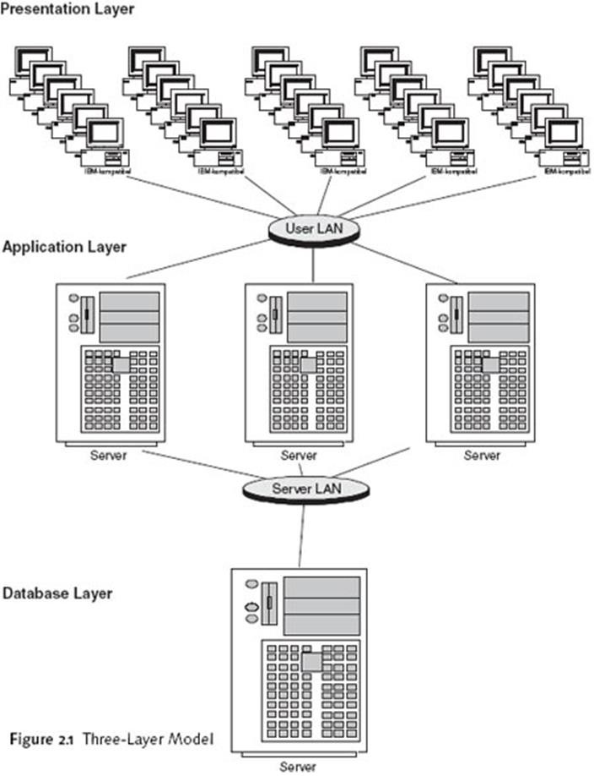

**Figure1: SYSTEM ARCHITECTURE**

# MODULUS

* + 1. **Steps to create database table:**

## Step 1 - Enter new table name

Using transaction SE11, ensure the "Database table” radio button is selected and enter a name for your new table into the input box. For this example I am going to create a table called ZCOLLEGE.

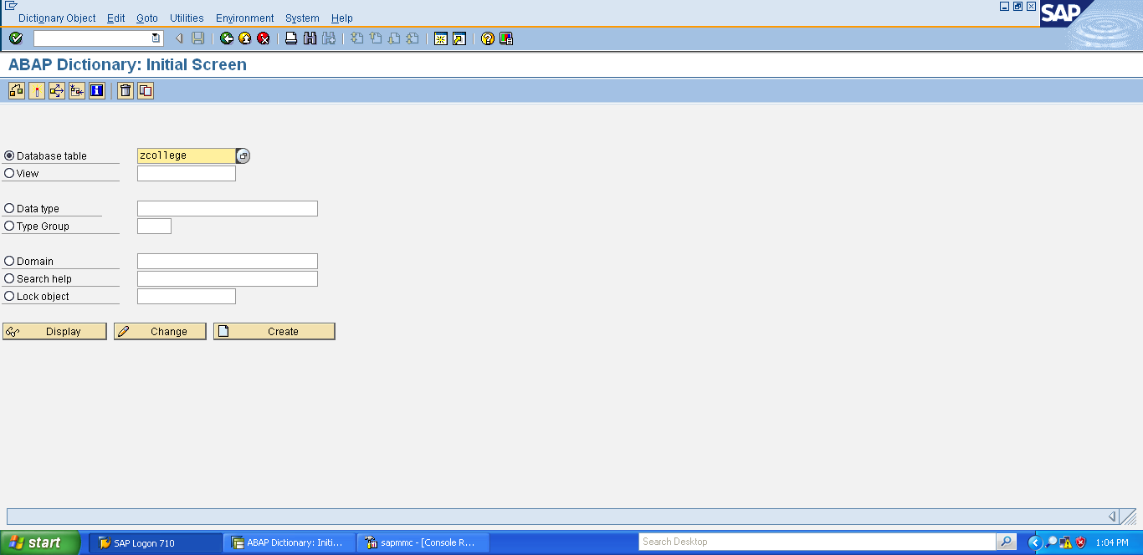

Figure2: Database table

**Step 2 - Enter basic details**

With the 'Delivery and Maintenance' tab enter a short description, set delivery class to A and choose Display/Maintenance Allowed for the 'Data Browser' option. See table settings for more details about these options and their effects on the table.

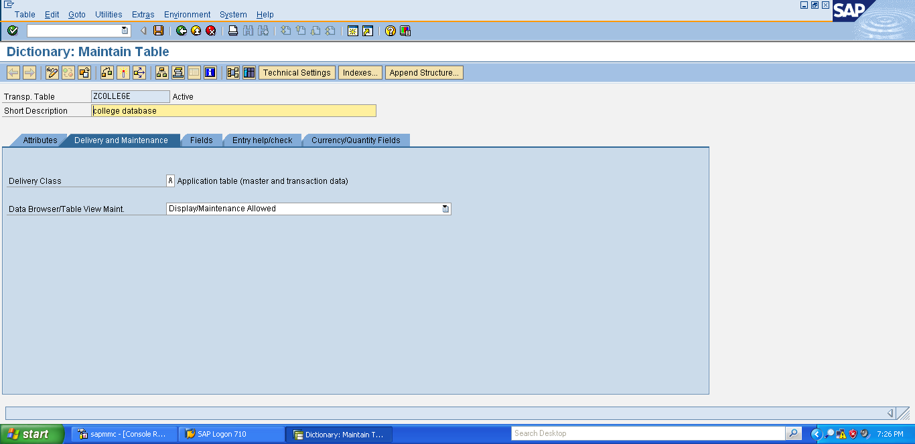

Figure3: basic system

**Step 3 –create Domains**

Now go to domain tab. Create domains such as zname .similarly create domains needed for the database table.

Finally, save and Activate the domains.

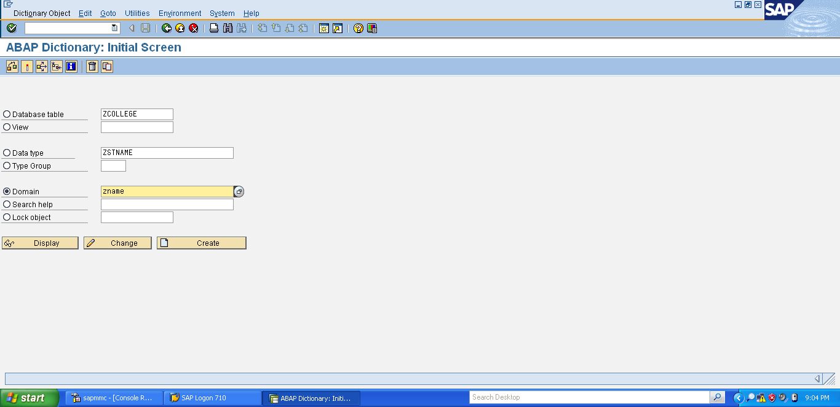

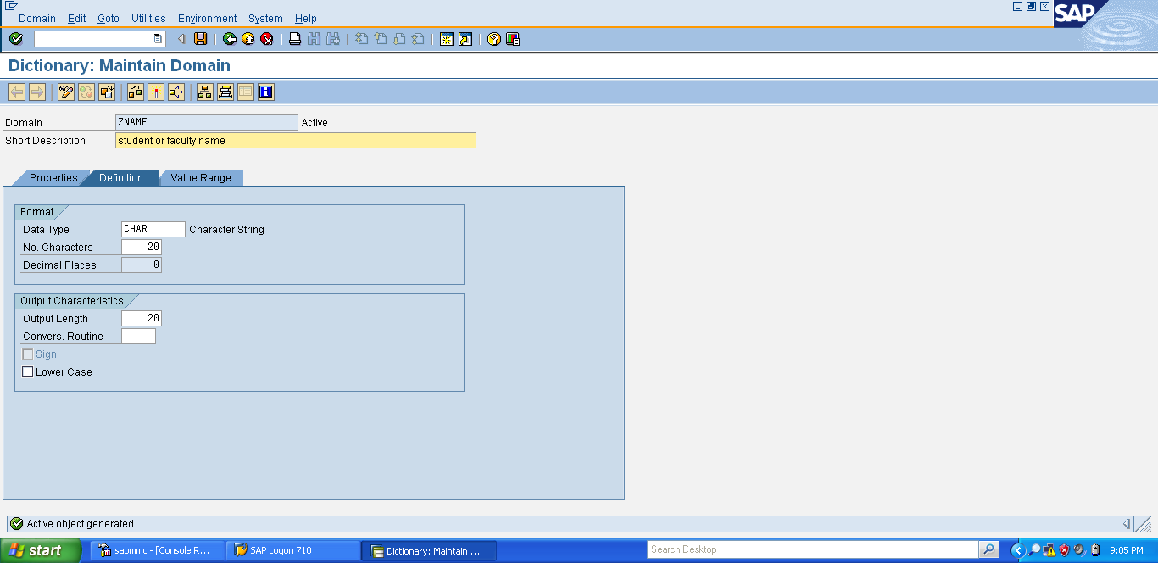

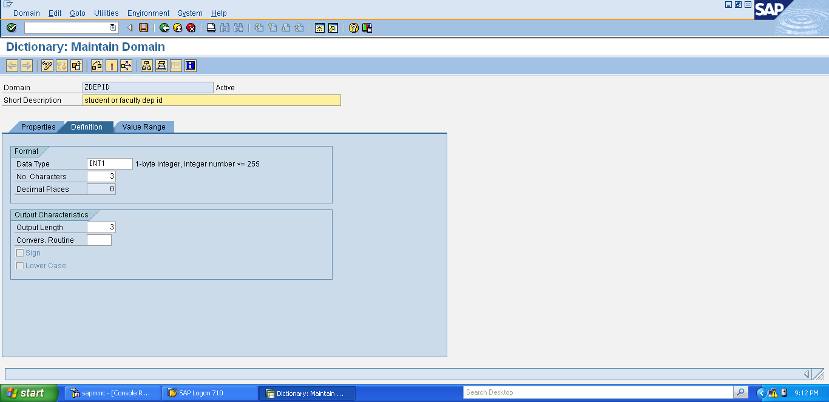

Figure4: create domain

**Step 4 - Enter field names**

Now go to the fields tab and add some fields such as **zstname**. Similarly create more fields for the database table.

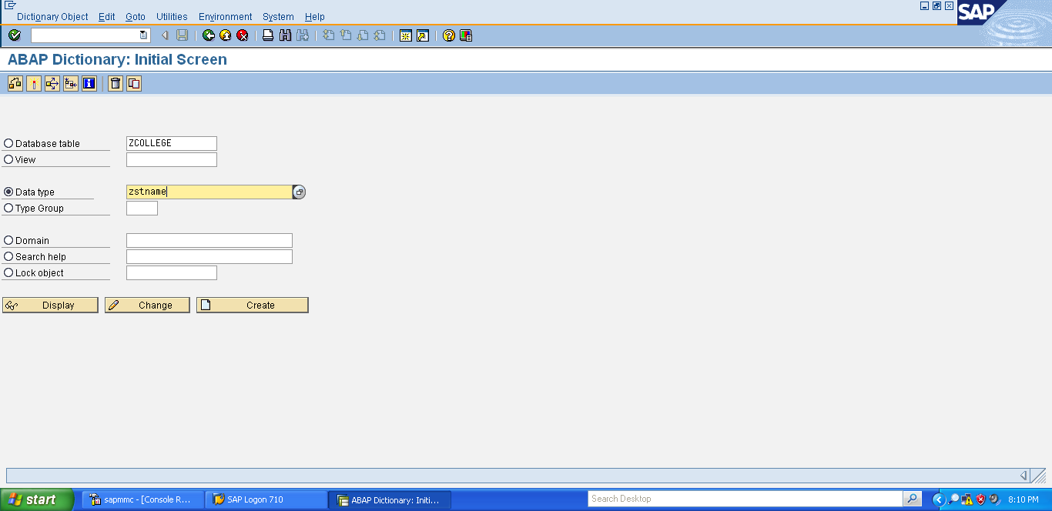

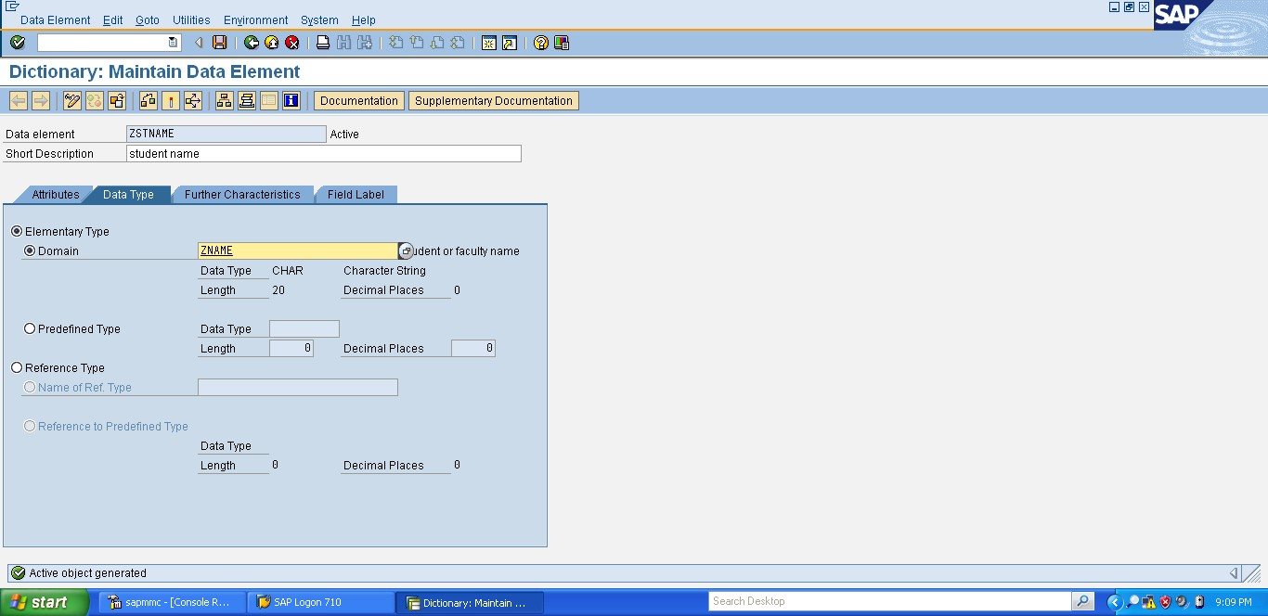

Figure5: enter field names

**Step 5 - Enter technical settings**

Before you can activate your new table you need to maintain the technical settings to define the type and size of data being stored. To do this first Click on the

Go to->Technical Settings option

on the next screen enter the data class as 'APPL0' and the size as '0'.

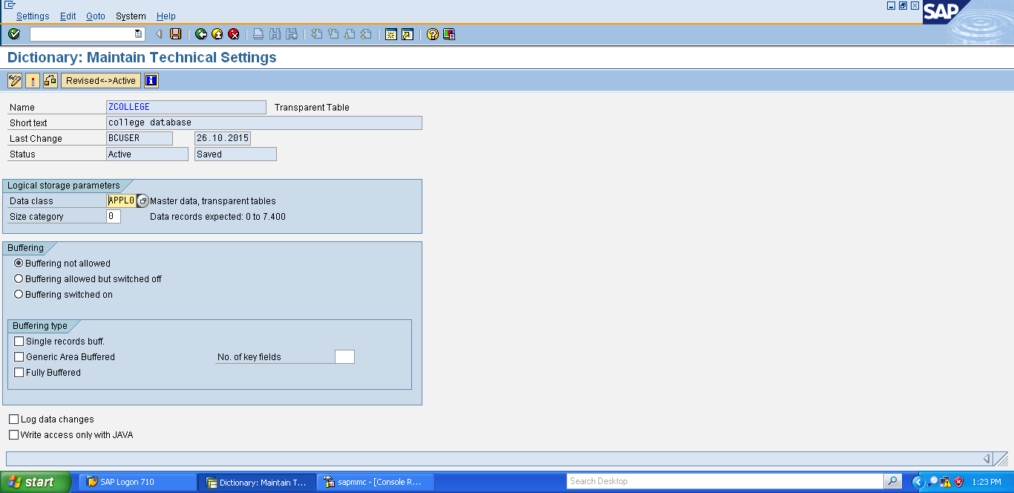

Figure6**:** Enter technical settings

**Step 6 - SAVE, Activate and your done**

Right that’s it, simply save and activate your table and its ready to use.

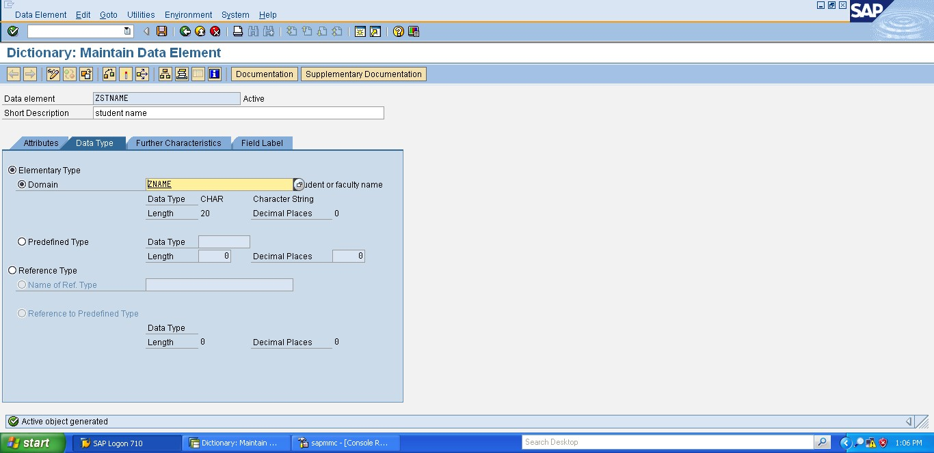

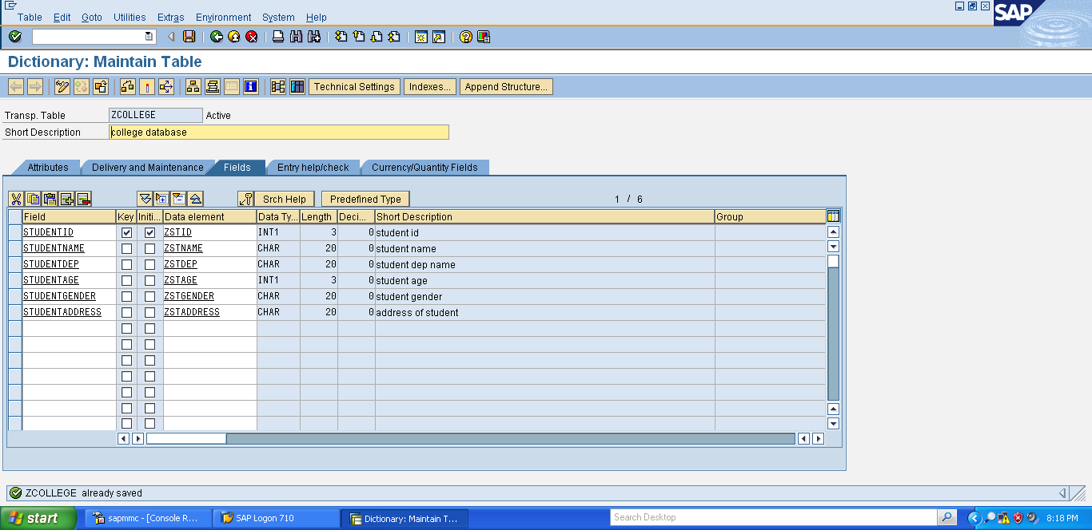

Figure7: SAVE, Activate and your done

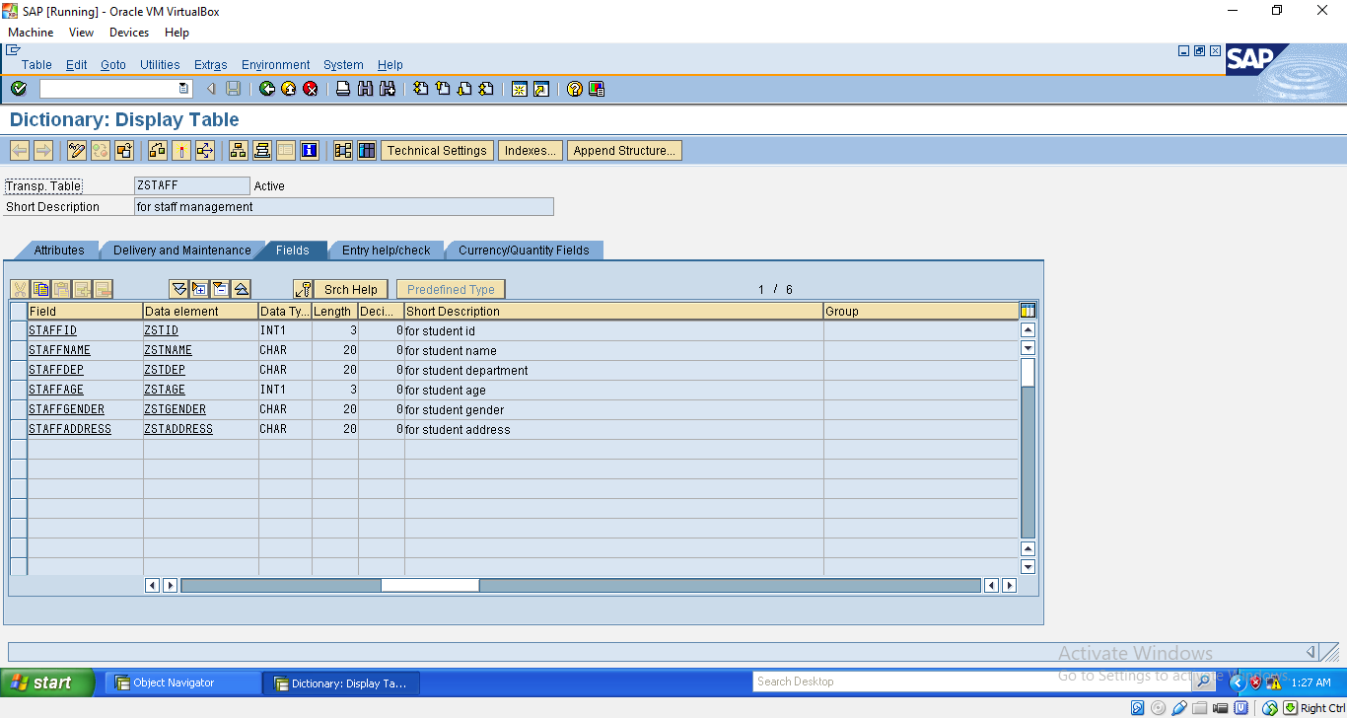

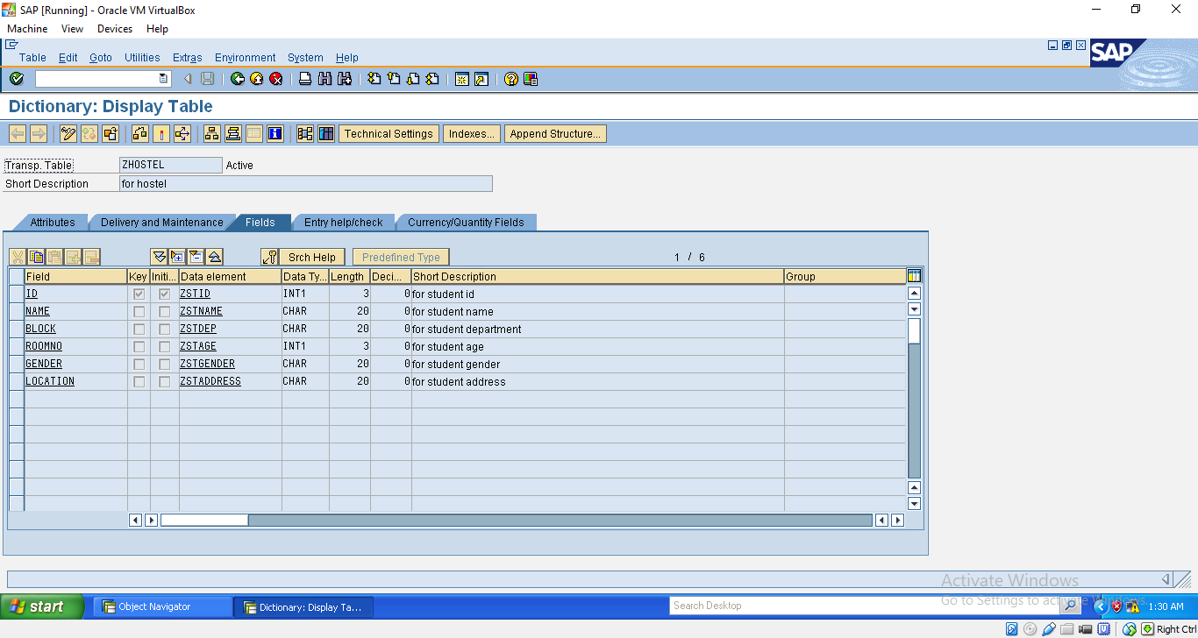

* + 1. **STEPS FOR SCREEN DESIGNING Step1-CreateNewdialogProgram**

Within transaction SE80 select program from the dropdown and enter a Z name for your custom SAP program (i.e. ZCOLLEGES). Now press enter, select "With TOP INCL." and press the Yes button Enter a name for your top include (i.e. ZCLGTOP) and press the green tick Within the attributes screen simply enter a title and press the save button

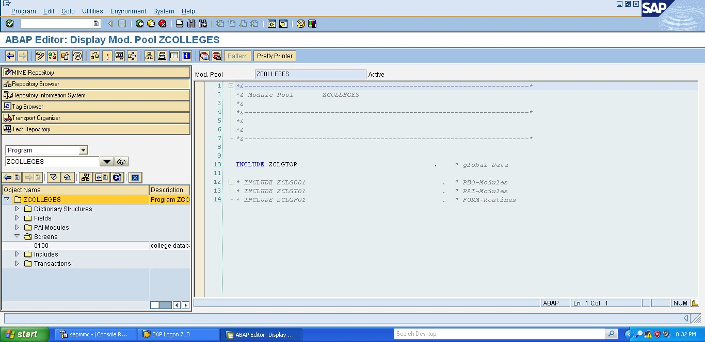

## Step 2 - Add a screen to your dialog program

You now need to add a screen to your program by right clicking on the program name and selecting the options Create->Screen

Enter a screen number such as '0100' and press the green tick

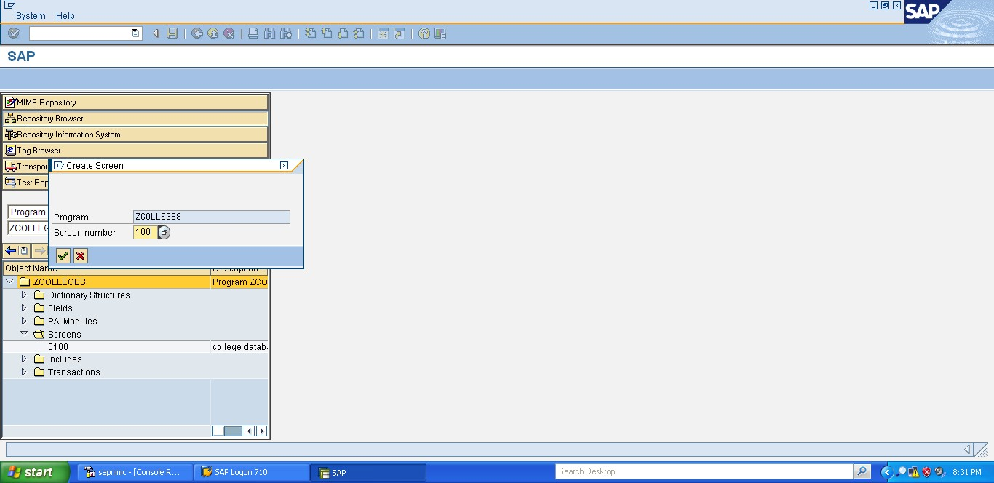

On the next screen enter a short title, set to normal screen type and press the save button on the top application toolbar!

## Step 3 - Screen layout

Now click on the layout button within the application toolbar. Here we also need to create a PUSH BUTTON to display the contents of table.

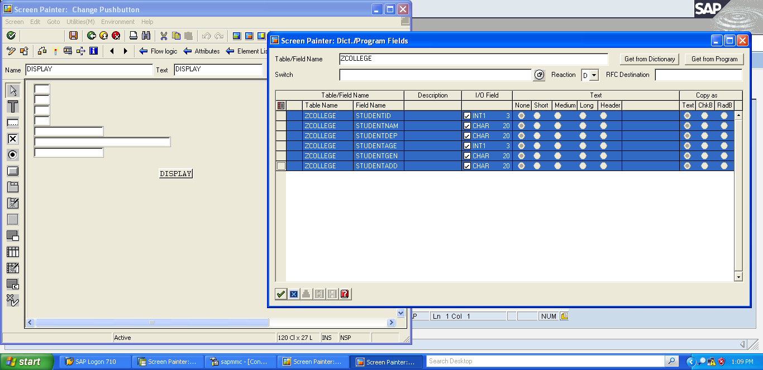

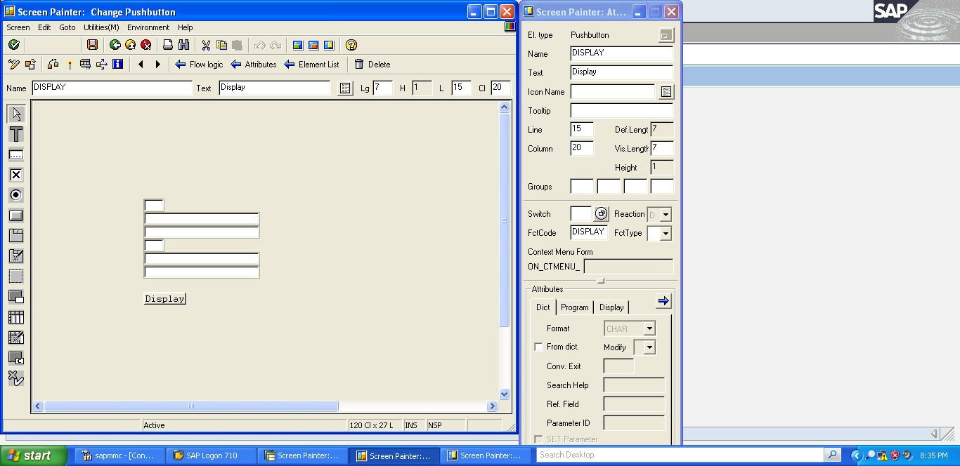

## Step 4 - Create transaction

Next step is to create a transaction code for your program, to do this simply right click on the program name choose the option Create->Transcation

Enter a transaction code such as 'Z11'

Enter transaction text, program / Screen you have just created (i.e. ZCOLLEGES / 0100 ) and tick at least the SAPGUI for Windows checkbox.

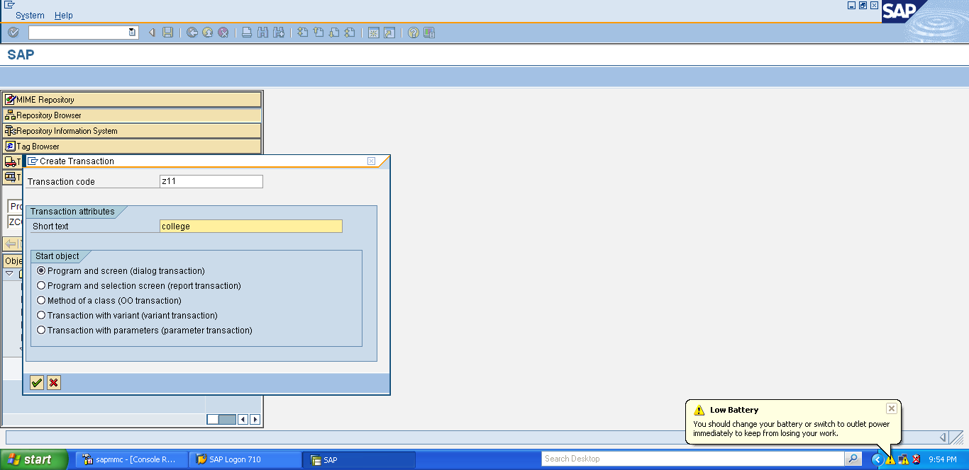

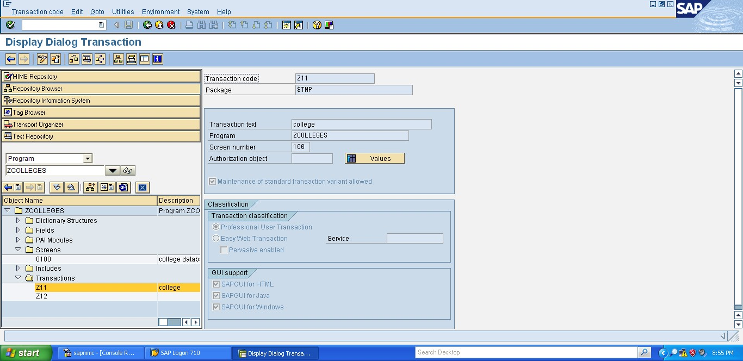

## Step 5 - Test

First Save and activate everything. You can now execute the program by using the transaction code you have just created. note the /o at the begining executes the transaction in a new session. Your program should then be executed and the text you entered displayed onscreen.

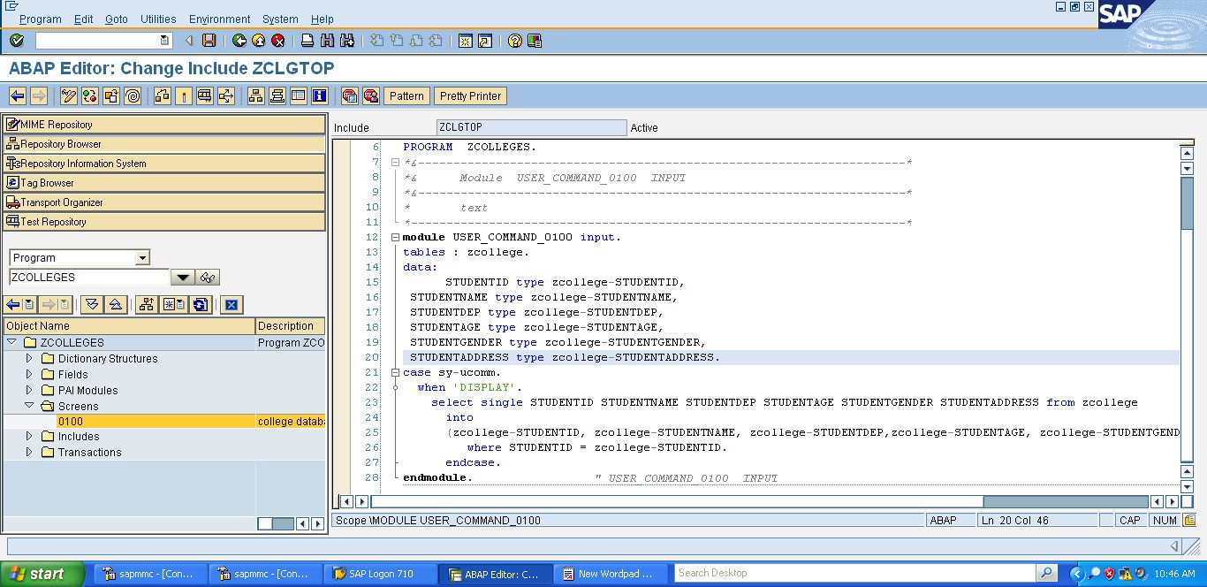

## Coding :

In this project we create four screens , for each screen we need to add the codings

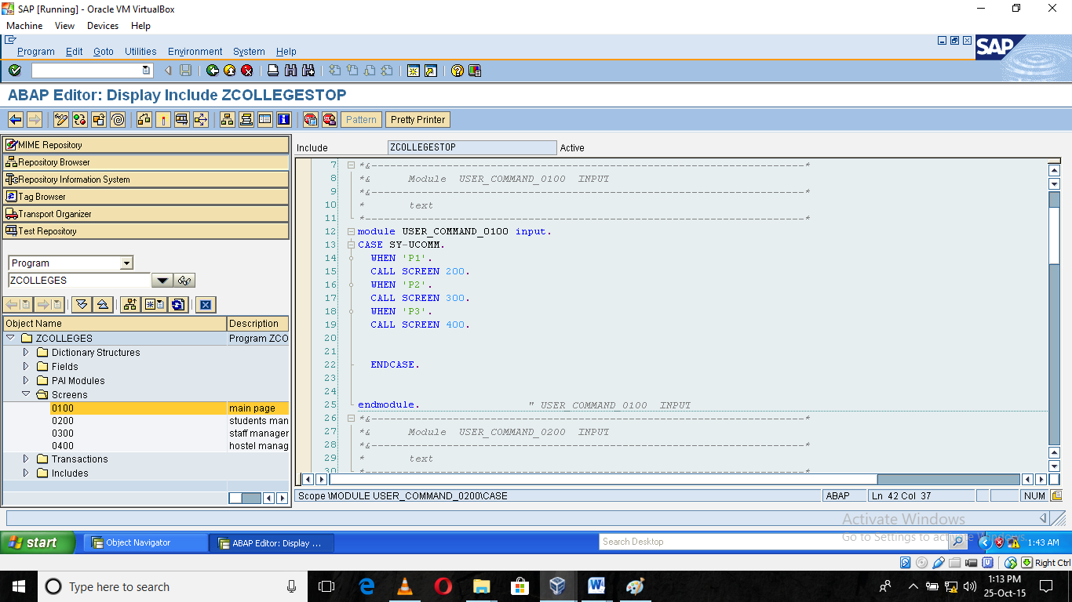

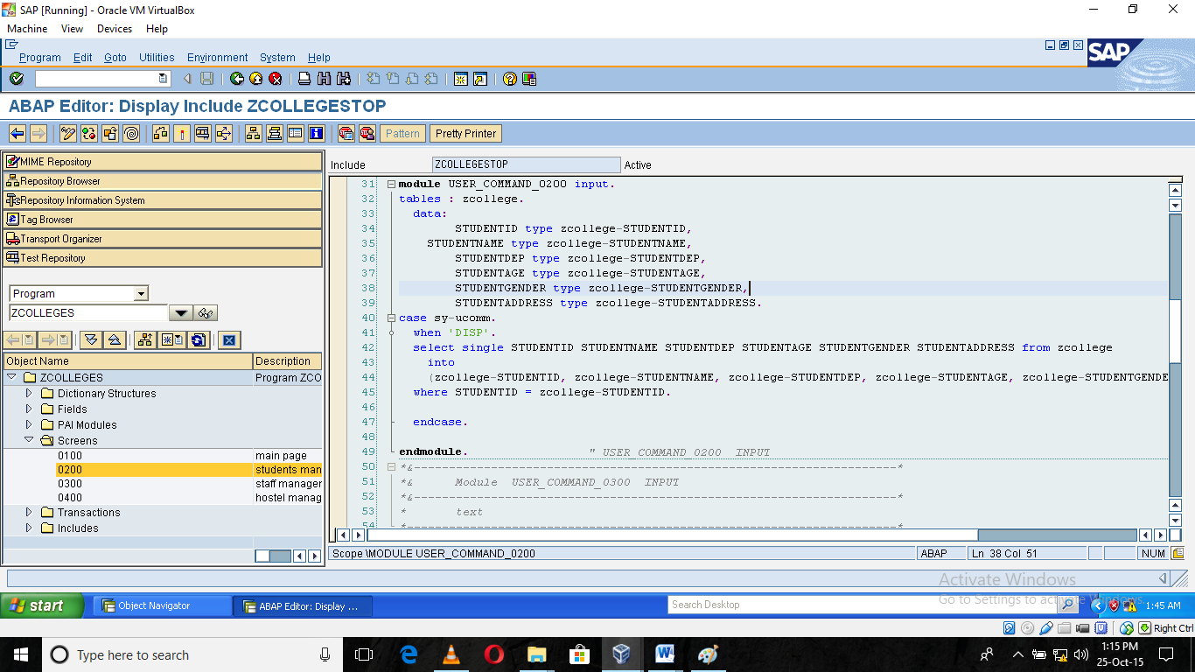

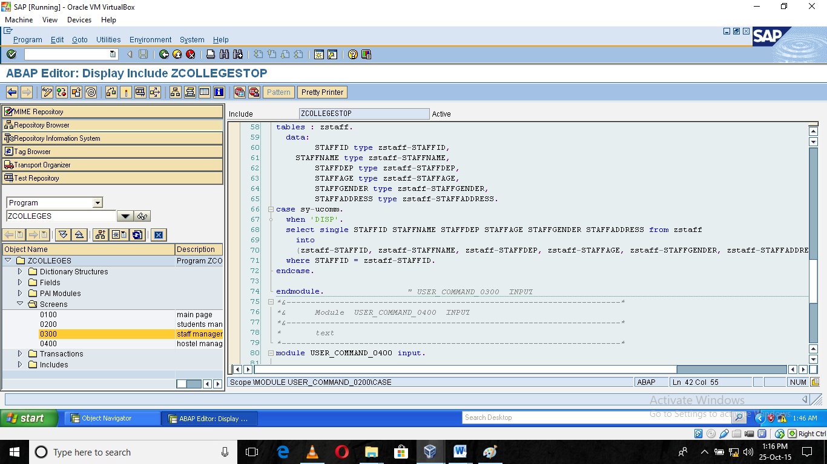

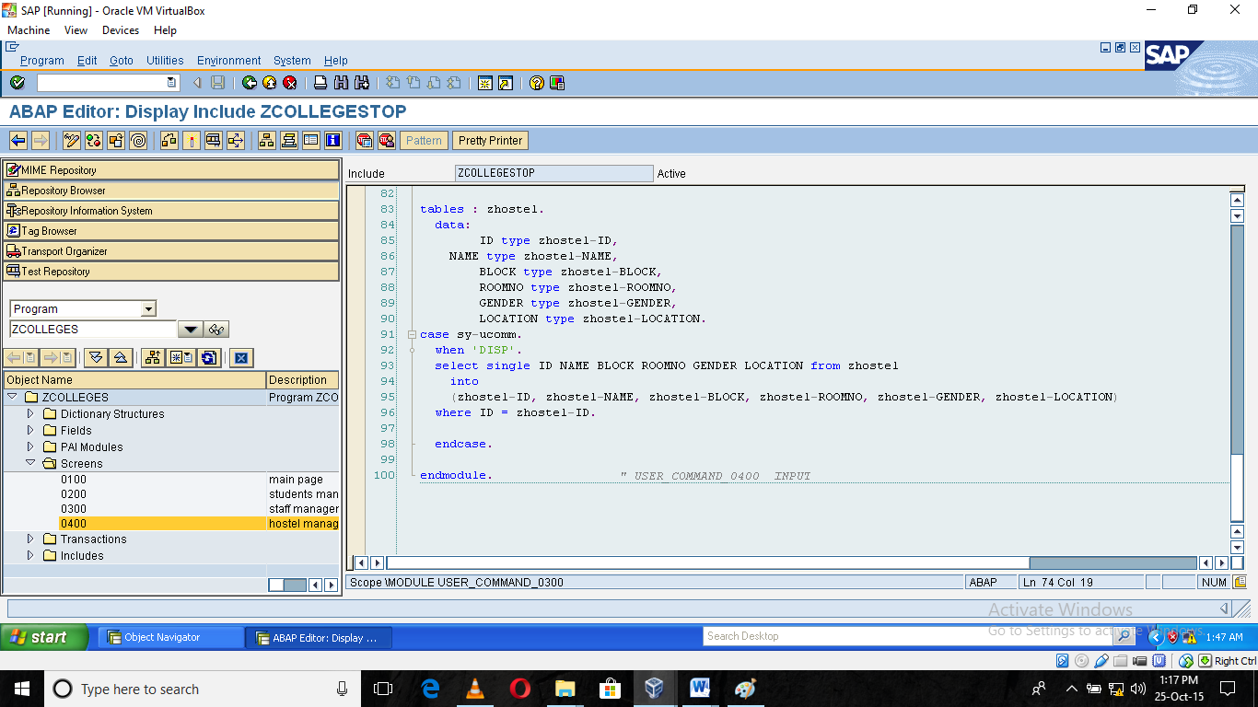

## DATA RETRIEVAL

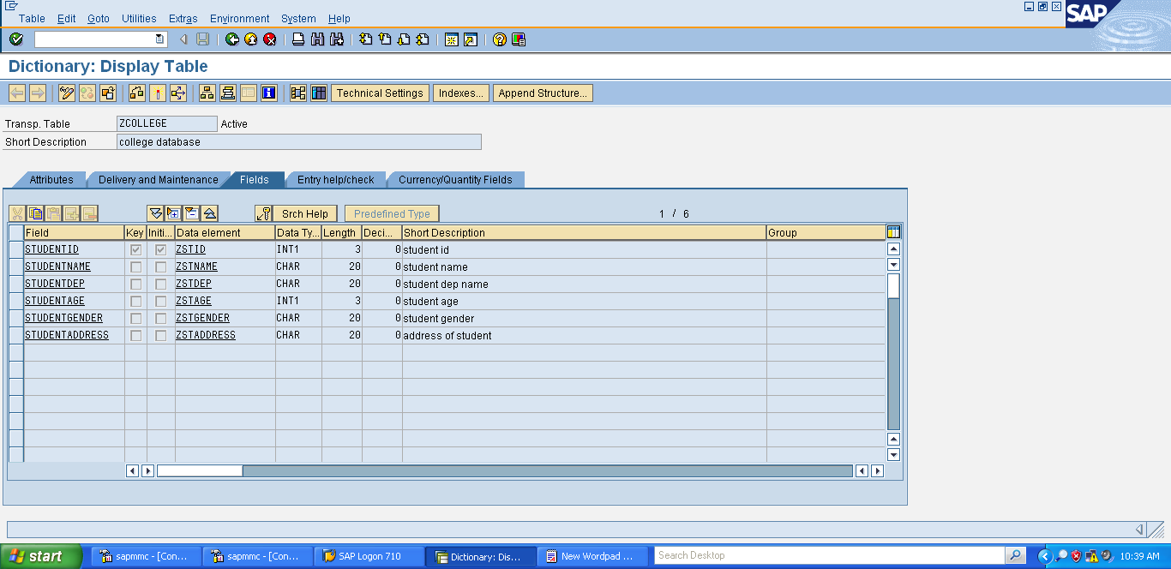

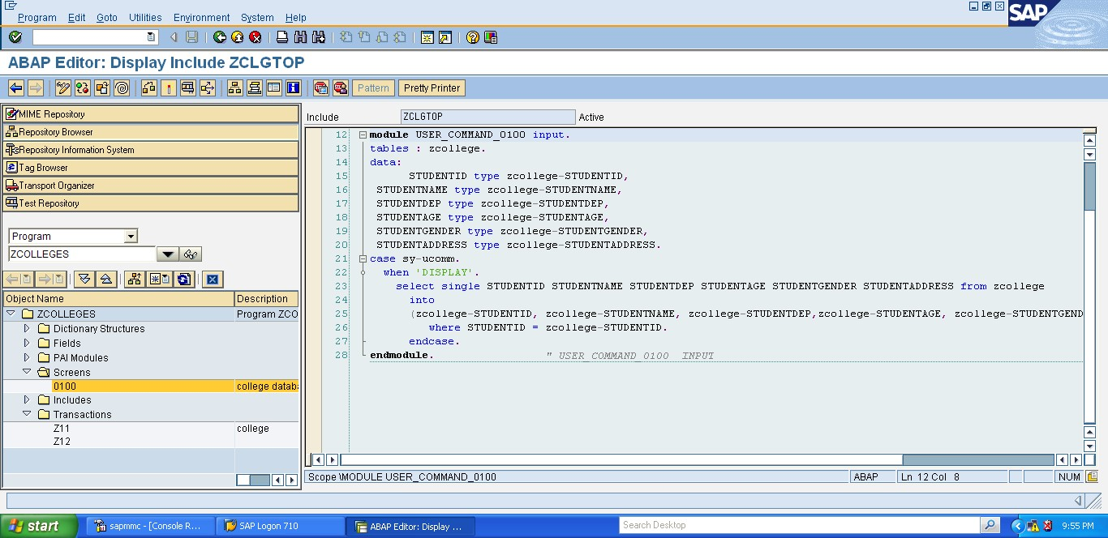

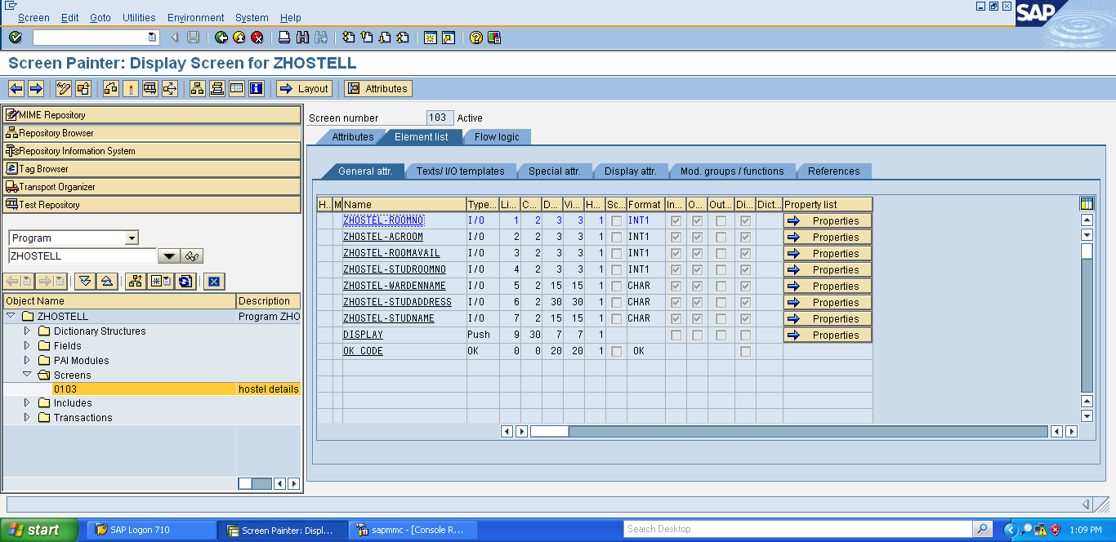

**Output :**

**we can also execute the program by clicking execute and then direct processing**

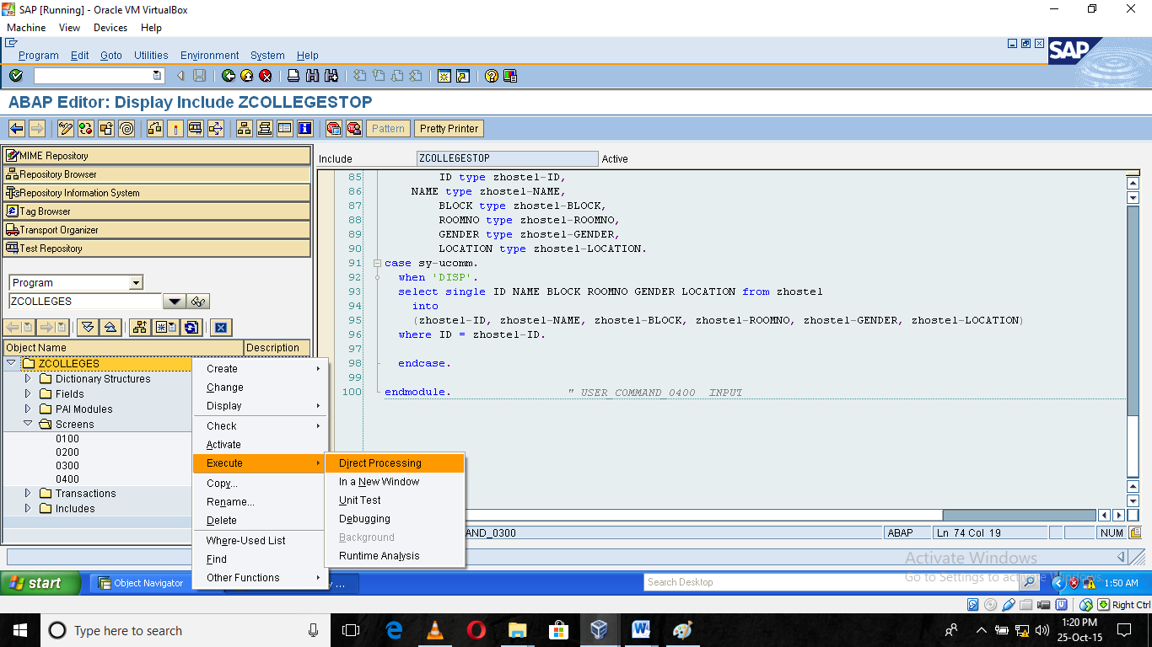

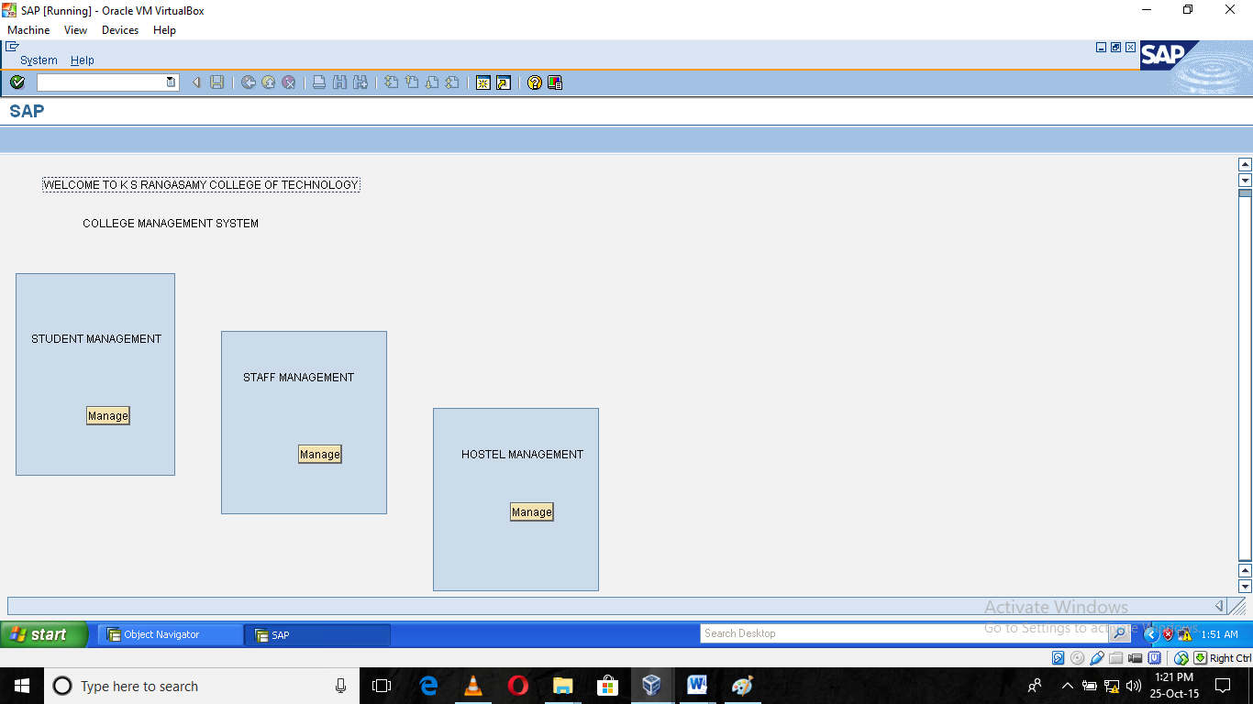

**Screen 2 :**

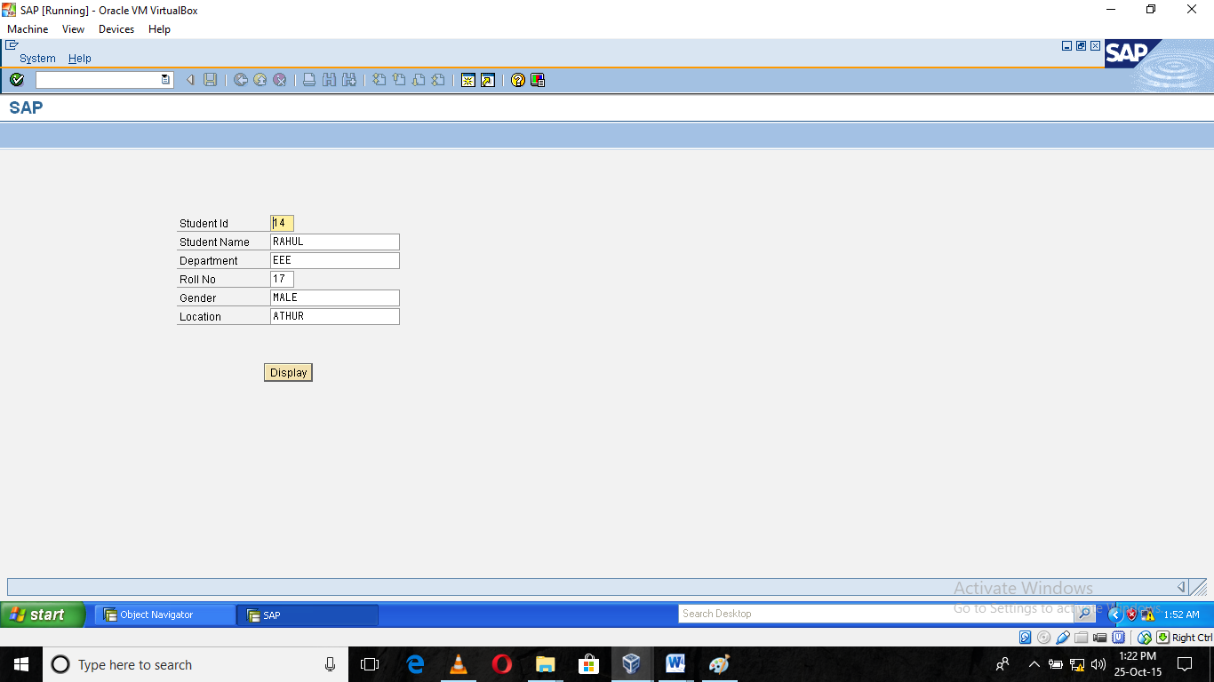

**In the execution , there is unable to go to previous screen that’s why we can use the trasanction code to execute**

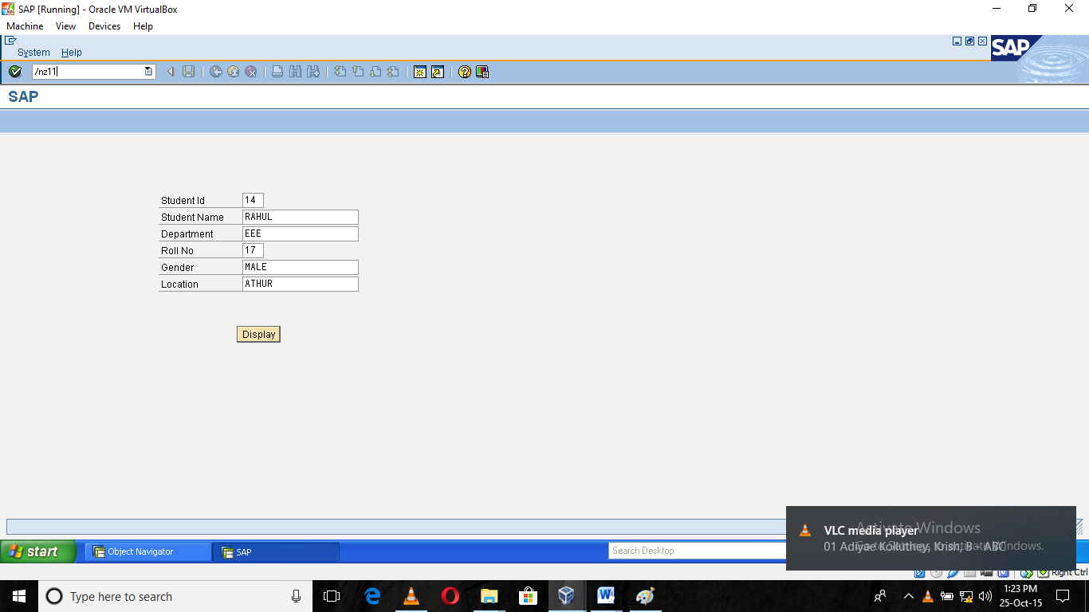

**Screen 3 :**

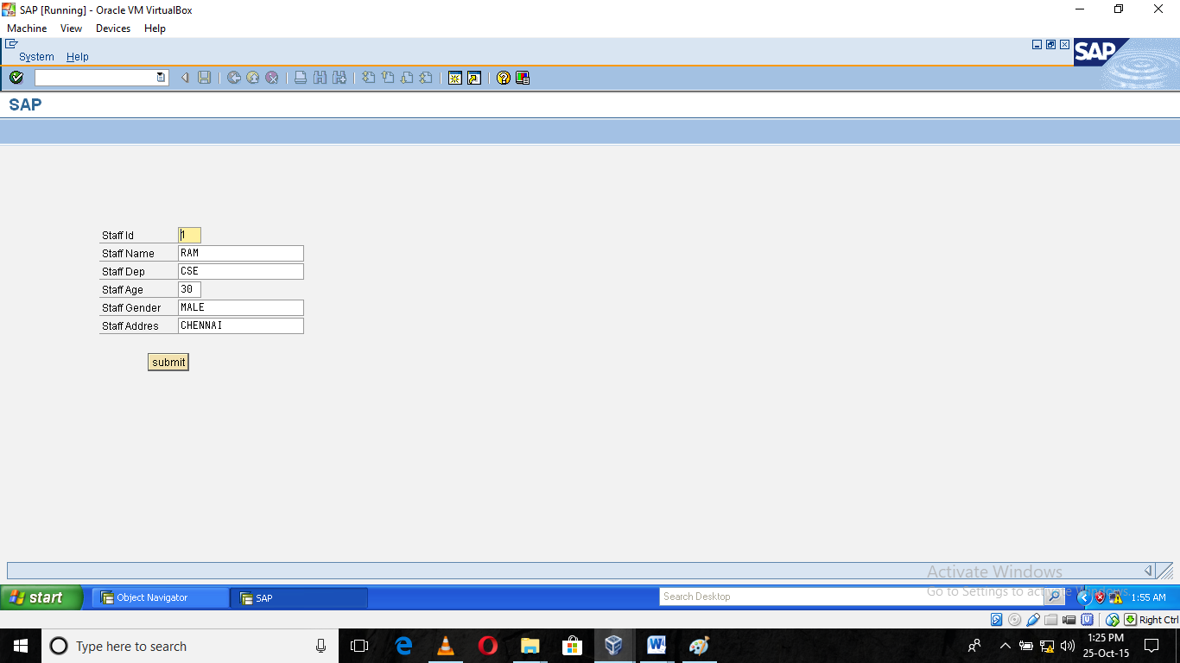

**Screen 4 :**

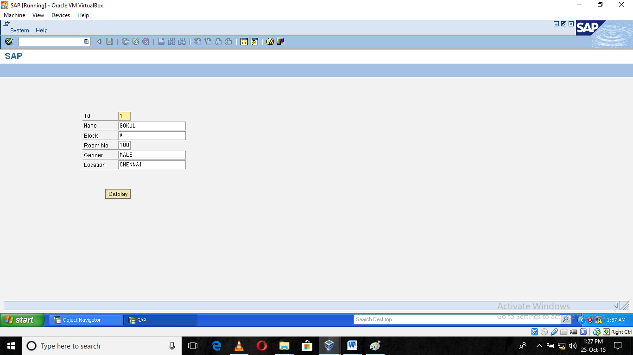

**TRANSACTION CODES USED**

* + - * Se80-object navigator
      * /nse80-home page of object navigator.
      * Se11-To create table,domains,data types
      * /nse11-To home page of create table,domains,data types
      * Se16-To create entries for a table
      * Z11-program transaction code

## DOMAINS CREATED

* + - * Zname(for name,address,gender,department)
      * Zdepid(for age, id, )

## DATA FIELDS CREATED

* + - * Zstid(for student id ,staff id , hostel id)
      * Zstname(for student name , staff name)
      * Zstaddress(for student address ,staff address , location )
      * Zstgender(for student gender)
      * Zstdep(for student department)
      * Zstage(for student age)

**DATABASE TABLE:**

* Zcollege
* zstaff
* zhotel

**SCREEN PROGRAM NAME**: zcolleges

**TOP INCLUDE NAME**: zclgs

**SCREEN NUMBER**: 100 ,200,300,400

**PUSH BUTTON NAME**: display,

**FET CODE**: display , disp

## CONCLUSION

This case study incorporate all activities required to access college database It provides all necessary information to the management as well as the student with the use of this system. The user can simply sit in front of the system to monitor each and every query related to college. Database can service the student faculty requests best in time.

REFERENCES:

1. https://help.sap.com/saphelp_46c/helpdata/en/32/419337333fb436e1000000 9b38f8cf/frameset.htm

2. https://help.sap.com/erp_hcm_ias2_2014_03/helpdata/en/b8/047a31e5554d9 aabda408ebcb7a41b/frameset.htm

v